OMT Test: Low Order/High OMT Count Test

This document describes a test case with following objectives.
- Test the routing of orders to multiple OMTs by OHS based on routing properties.
- Test simultaneous login by large number of OMTs
- Steady order rate response time impact from large number of simultaneous OMT login.
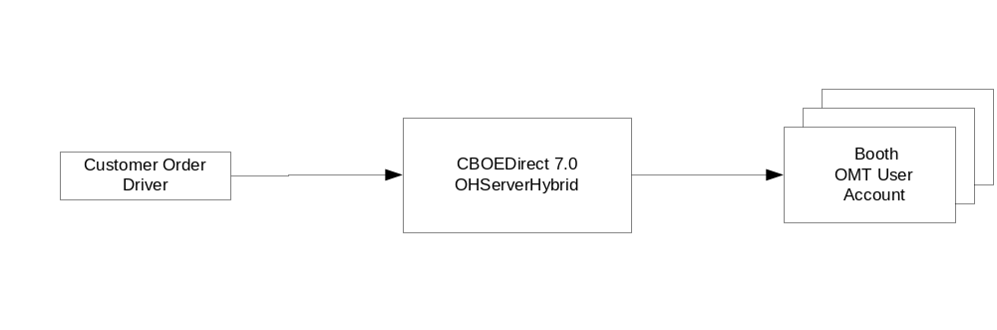
Figure 1: Orders routed to many OMTs

PART 1: Test Procedure

The part 1 of this test is to test the accuracy in the count of OMT messages received upon OMT login.

- Place addPerfOmtTestRoutingProperties script in $RUN_DIR/tmp on the GC running the master GlobalServer.
- Execute $RUN_DIR/tmp/addPerfOmtTestRoutingProperties. This script will produce a setBoothDefaultDestForOMTTest.csv file in $RUN_DIR/tmp. The .csv file sets routing properties to route all incoming orders to 45 Booth OMTs.
- Run ITG client with the setBoothDefaultDestForOMTTest.csv. This will create BoothDefaultDestination routing properties. Use the same firm number for setting these properties as you plan to use in the order driver.
- Set following additional session-firm level routing properties using the SA GUI. The session-firm level routing properties is one where the trading class is “Default” such that the single session-firm level routing property applies to orders of all trading classes for the session and firm specified by the routing property.
  - Firm Volume Limit Simple Order. Set this value to 500.
  - Volume Deviation Check Simple Order. Set to following values.
    - Volume = 500
    - Level = 1
    - Deviation = ALL
    - Destination = TE
- Start the order driver with following parameters.
  - Firm value should be the same firm value used in the addPerfOmtTestRoutingProperties script.
  - Order rate = Steady 50 orders/sec
  - Cancel rate = 25%
  - Fill Rate = 10%. This need not be exact, but some significant number of fill should occur while the order driver is running.
  - Customer orders with NONE contingency.
- Run the order drivers for approximately 10 minutes or at least long enough duration to accumulate approximately 100 orders at each Booth OMTs. Run the following query repeatedly until the OMT location with highest number of order is 75 orders. This query will display the number of orders at each OMT. The query result is sorted from the OMT with least number of orders to OMT with highest number of orders.
  - select count(*) as cnt, location from sbtorder group by location order by cnt asc
- Setup the OMT login driver for simultaneous login of all OMTs used in the setBoothDefaultDestForOMTTest.csv. Use the following parameters for OMT Login driver.
  - Number of login attempts = 10
  - Remain login time = 2 minutes
  - Time between login = 30 seconds.
  - Number of OMTs = The first 44 OMTs from the 45 OMTs used in this test.
- Start OMT log-in/log-out driver to login all Booth OMT users.
- When OMT login driver is executing to login 44 OMT users, login the 45th OMT using Trader GUI.
  - Open the OMT Message Window
  - Confirm that the OMT Message Window shows the correct number of orders, cancel report drop-copy and fill report drop-copy count. Note that the fill report drop-copy and cancel report drop-copy messages are combined in the OMT Message Window under the Drop-Copy tab.
- Repeat step 9 at least twice during the time when OMT Login driver is running, preferably during the time when the OMT Login driver itself is logging-in the other 45 OMTs.

PART 2: Test Procedure

The part 2 of this test is to test the impact on order processing response time while large number of OMTs are logging-in simultaneously.

- Setup the order driver with following parameters.
  - Firm value should be the same firm value used in the addPerfOmtTestRoutingProperties script.
  - Order rate = Steady 50 orders/sec
  - No Cancel and No Fill
  - Customer orders with NONE contingency.
- Setup the OMT login driver for simultaneous login of all OMTs used in the setBoothDefaultDestForOMTTest.csv. Use the following parameters for OMT Login driver.
  - Number of login attempts = 5
  - Remain login time = 2 minutes
  - Time between login = 1 minute.
  - Number of OMTs = 45 OMTs used in Part 1.
- Start the order drivers.
- After 5 minutes of the order driver execution, start the OMT Login Driver.
- Once all iterations of OMT Login Driver are completed, leave the order driver running for additional 5 minutes.
- Once the order driver is stopped, collect the usual response time statistics.

Post-Test Cleanup
- Remove all routing properties setup for this test using the SA GUI. These routing properties are:
  - All Booth Default Destination values setup by addPerfOmtTestRoutingProperties.
  - Remove the session-firm level Firm Volume Simple Limit order for the firm used in the test.
  - Remove the session-firm level Volume Deviation Check Simple Order order for the firm used in the test.

